KUBERNETES TASK 09
Execute all the steps shown in video.
Upgrade k8s cluster from 1.29 to 1.34 Version. Note: Document to upgrade cluster.
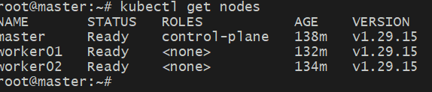
Hold packages (prevents accidental auto-upgrades)
sudo apt-mark hold kubeadm kubelet kubectl
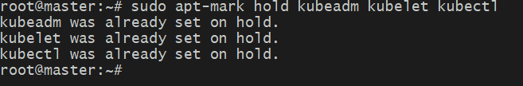
Drain the control plane
kubectl drain master --ignore-daemonsets --delete-emptydir-data
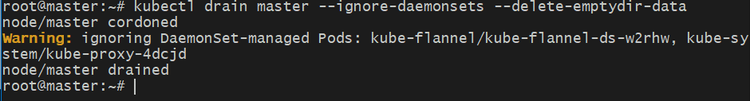
Remove old repo
sudo rm /etc/apt/sources.list.d/kubernetes.list
Add Kubernetes v1.30 repo
sudo mkdir -p /etc/apt/keyrings
curl -fsSL https://pkgs.k8s.io/core:/stable:/v1.30/deb/Release.key \
| sudo gpg --dearmor -o /etc/apt/keyrings/kubernetes-apt-keyring.gpg

echo "deb [signed-by=/etc/apt/keyrings/kubernetes-apt-keyring.gpg] \
https://pkgs.k8s.io/core:/stable:/v1.30/deb/ /" \
| sudo tee /etc/apt/sources.list.d/kubernetes.list
sudo apt update
apt-cache madison kubeadm
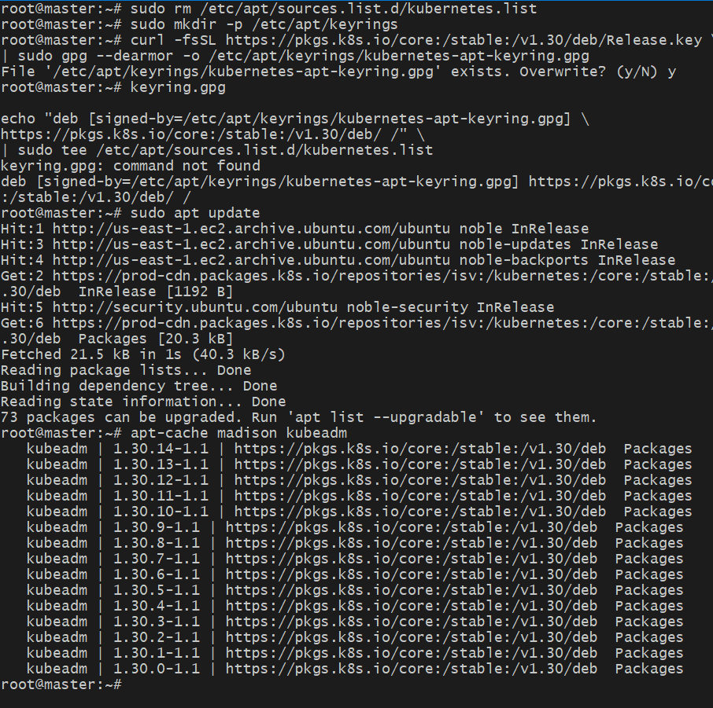
Now upgrade the cluster (this will work)
sudo kubeadm upgrade plan
sudo kubeadm upgrade apply v1.30.0-1.1

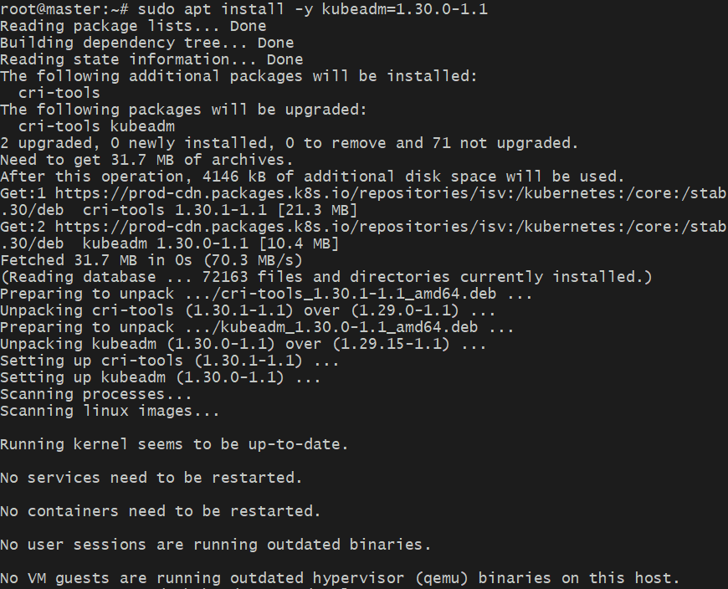

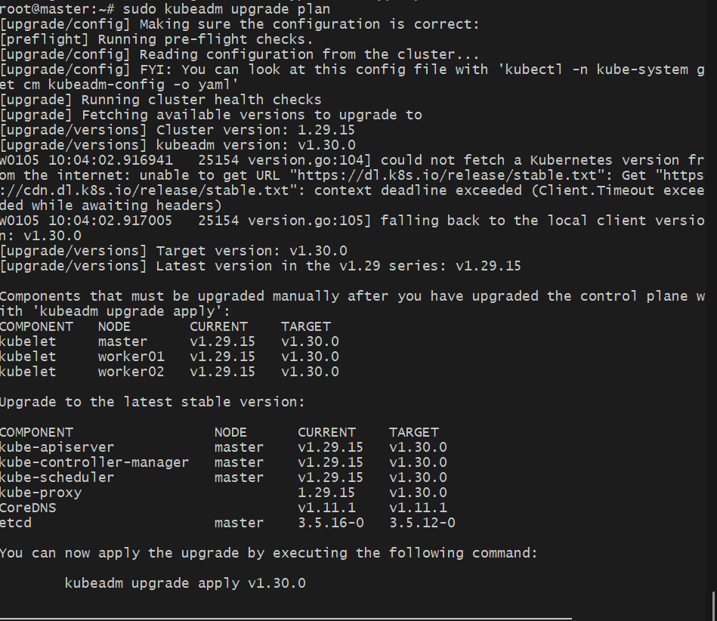
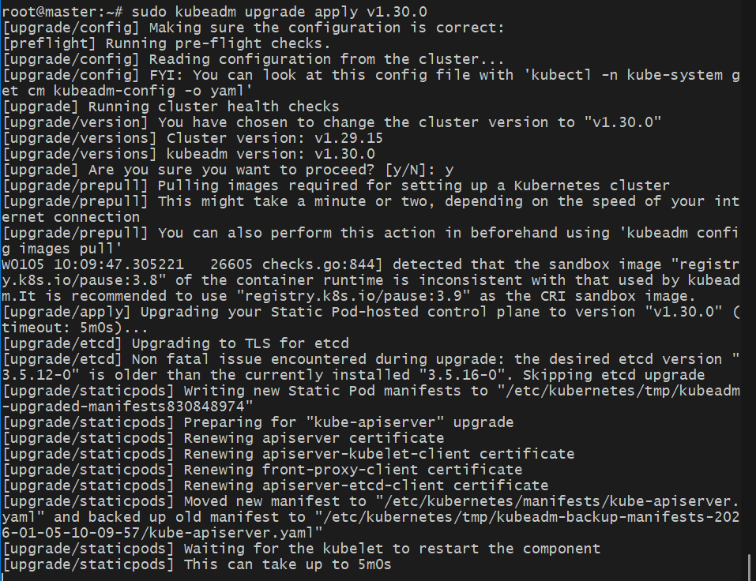

Upgrade kubelet & kubectl
sudo apt install -y kubelet=1.30.0-1.1 kubectl=1.30.0-1.1
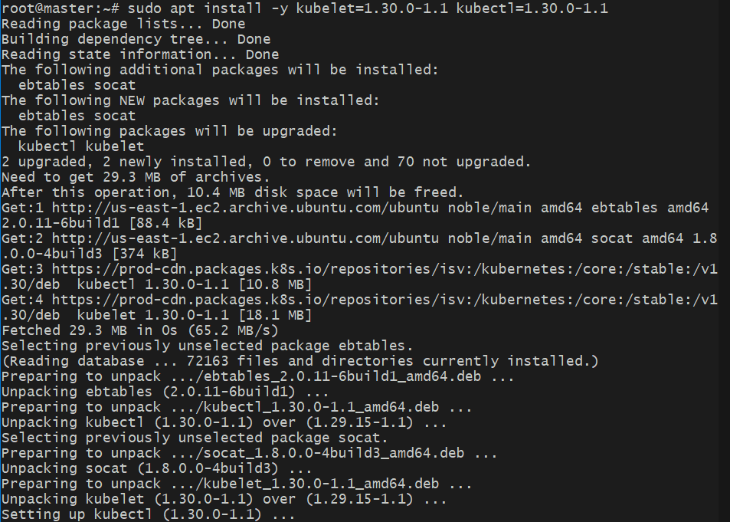
sudo systemctl daemon-reload
sudo systemctl restart kubelet
kubectl get nodes
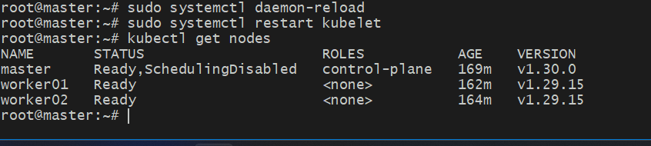
Log into worker nodes
Worker01:
sudo apt-mark hold kubeadm kubelet kubectl
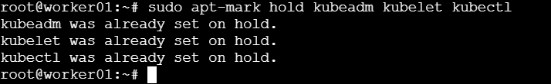

kubectl drain worker01 --ignore-daemonsets --delete-emptydir-data
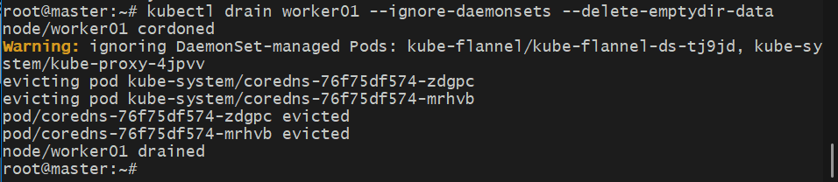
Remove old repo
sudo rm /etc/apt/sources.list.d/kubernetes.list
Add Kubernetes v1.30 repo
sudo mkdir -p /etc/apt/keyrings
curl -fsSL https://pkgs.k8s.io/core:/stable:/v1.30/deb/Release.key \
| sudo gpg --dearmor -o /etc/apt/keyrings/kubernetes-apt-keyring.gpg

echo "deb [signed-by=/etc/apt/keyrings/kubernetes-apt-keyring.gpg] \
https://pkgs.k8s.io/core:/stable:/v1.30/deb/ /" \
| sudo tee /etc/apt/sources.list.d/kubernetes.list
sudo apt update
apt-cache madison kubeadm
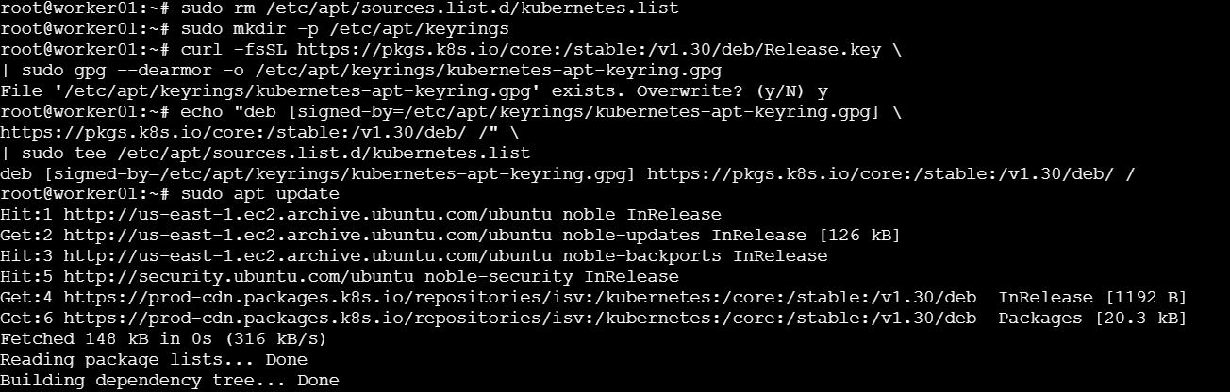
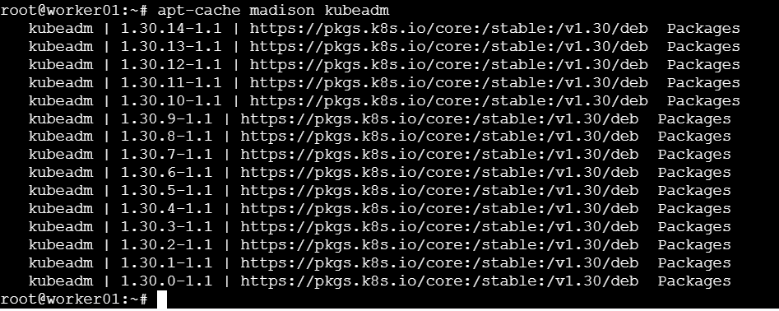
Now upgrade the cluster (this will work)
Run on master
sudo kubeadm upgrade plan
sudo kubeadm upgrade apply v1.30.0-1.1
sudo kubeadm upgrade node
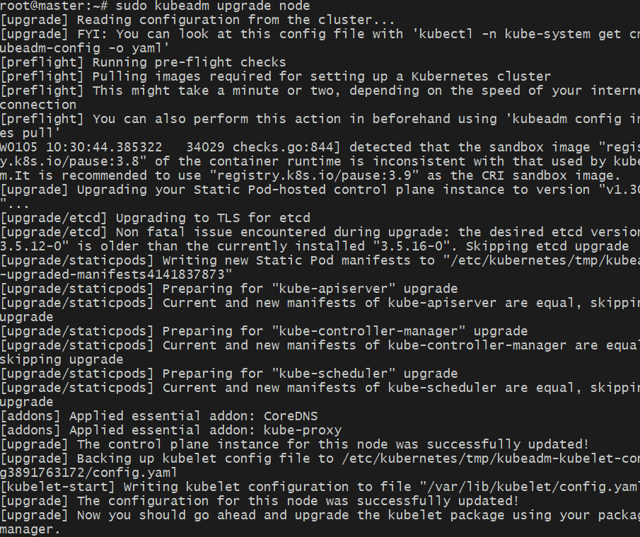

Kubectl get nodes
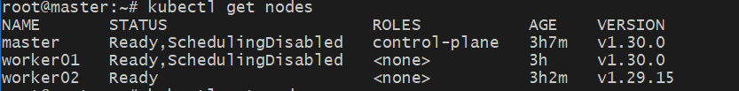
Worker02:
kubectl drain worker02 --ignore-daemonsets --delete-emptydir-datanode/worker02 cordoned
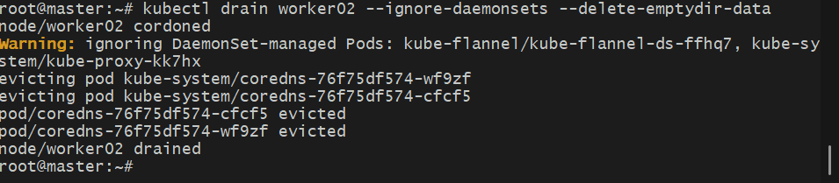
Remove old repo
sudo rm /etc/apt/sources.list.d/kubernetes.list
Add Kubernetes v1.30 repo
sudo mkdir -p /etc/apt/keyrings
curl -fsSL https://pkgs.k8s.io/core:/stable:/v1.30/deb/Release.key \
| sudo gpg --dearmor -o /etc/apt/keyrings/kubernetes-apt-keyring.gpg

echo "deb [signed-by=/etc/apt/keyrings/kubernetes-apt-keyring.gpg] \
https://pkgs.k8s.io/core:/stable:/v1.30/deb/ /" \
| sudo tee /etc/apt/sources.list.d/kubernetes.list
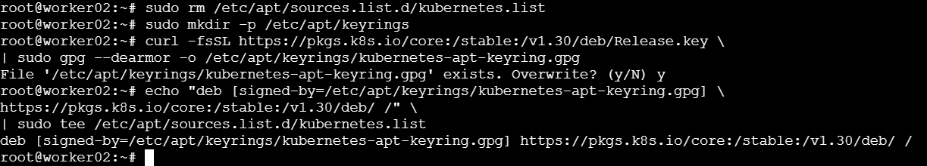
sudo apt update
apt-cache madison kubeadm
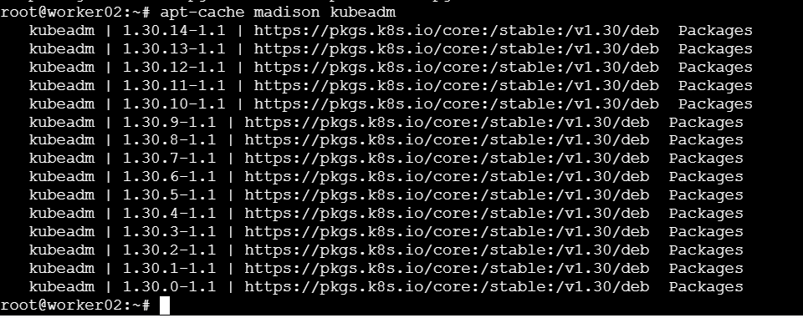
sudo apt install -y kubelet=1.30.0-1.1 kubectl=1.30.0-1.1
sudo systemctl daemon-reload
sudo systemctl restart kubelet
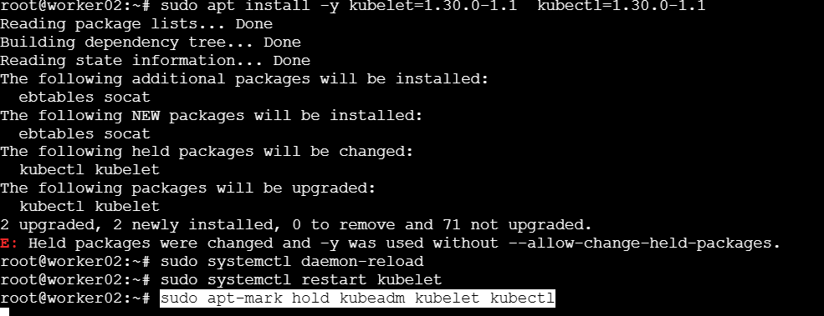
Uncordon nodes (from master)
worker02
kubectl uncordon worker02
(Optional) Uncordon master & worker01
Only do this after all nodes match:
kubectl uncordon master
kubectl uncordon worker01
